Practical 2
- WAP to perform insertion in a 1D array
Code – #include<iostream.h>
#include<conio.h>
void main()
{
clrscr();
int number;
cout<<"enter total number of element: ";
cin>>number;
int a[50];
int count=number;
cout<<"enter elements: ";
for(int i=0;i<number;i++)
{
cin>>a[i];
}
int k;
cout<<"enter the position where you want the element to be inserted: ";
cin>>k;
int b;
cout<<"enter the elementto be inserted: ";
cin>>b;
while(count>=k)
{
a[count+1]=a[count];
count--;
}
a[k]=b;
for(int j=0;j<=number;j++)
{
cout<<"after insertion: "<<a[j]<<"/n";
}
getch();
}

Output - 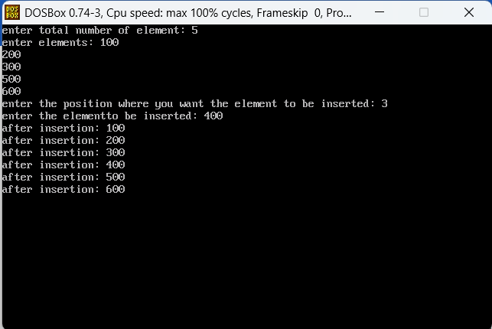

- WAP to perform deletion in a 1D array
Code – #include<iostream.h>
#include<conio.h>
void main()
{
clrscr();
int a[20],n,i,del,count=0;
cout<<"enter element to be entered: ";
cin>>n;
cout<<"enter the values:\n";
for(i=0;i<n;i++)
{
cin>>a[i];
}
cout<<"\Nenter the value to be deketed:\n";
cin>>del;
for(i=0;i<n;i++)
{
if(a[i]==del)
{
for(int j=i;j<(n-1);j++)
{
a[j]=a[j+1];
}
count++;
n=n-1;
break;
}
}
if(count==0)
{
cout<<"element not found";
}
else
{
cout<<"element deleted succesfully\n";
cout<<"new array:\n";
for(i=0;i<n;i++)
{
cout<<a[i]<<"\n";
}
}
getch();
}

Output -